**Are you ready for the BIG ONE?**

After the Philippine Institute of Volcanology and Seismology (PHIVOLCS)[released its high-resolution maps](http://www.rappler.com/move-ph/issues/disasters/93575-valley-fault-system-map-launch) on the Valley Fault System on May 18, web developers Dominic Tuazon, Louis Michael Concepcion, Mic Gutierrez, Kyle Abughanem, and Emmanuel Soriano – aka Team Instigators – created a website calculating how far one is from the West Valley Fault.

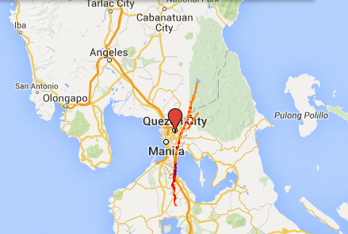

The affected cities and towns are as follows:

**West Valley Fault**

* Quezon City
* Marikina
* Makati
* Pasig
* Taguig
* Muntinlupa
* Bulacan (Doña Remedios Trinidad, Norzgaray, San Jose Del Monte City)
* Rizal (Rodriguez)
* Laguna (San Pedro City, Biñan, Sta Rosa, Cabuyao, Calamba)
* Cavite (Carmona, General Mariano Alvarez, Silang)

**East Valley Fault**

* Rodriguez, Rizal
* San Mateo, Rizal

**West Valley Fault High-Resolution Maps**

**Bagong Silangan**

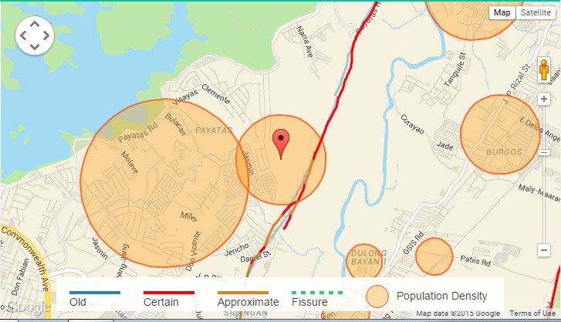

**Bagumbayan**

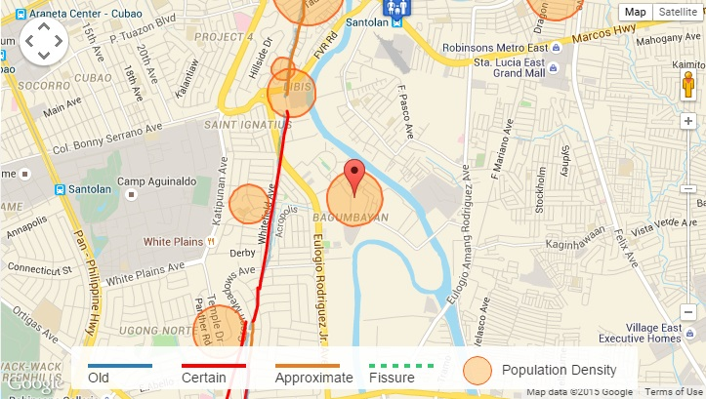

**Batasan Hills** 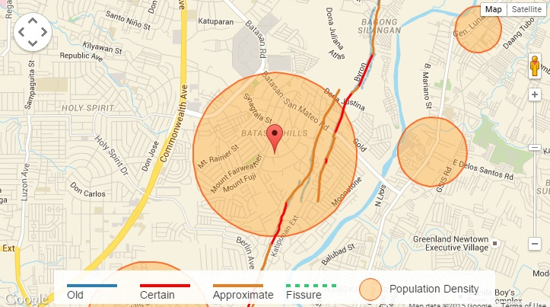

**Blue RidgeB & Libis**

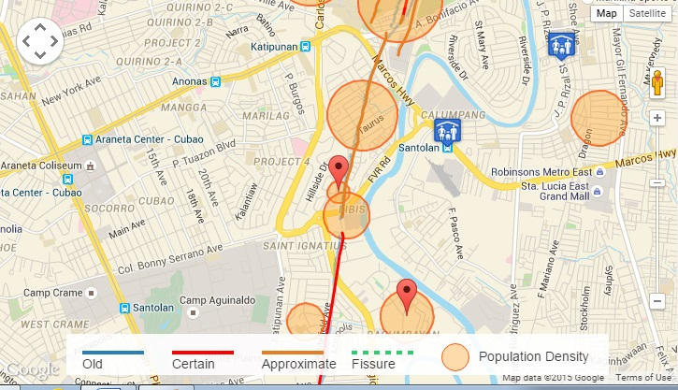

**Matandang balara**

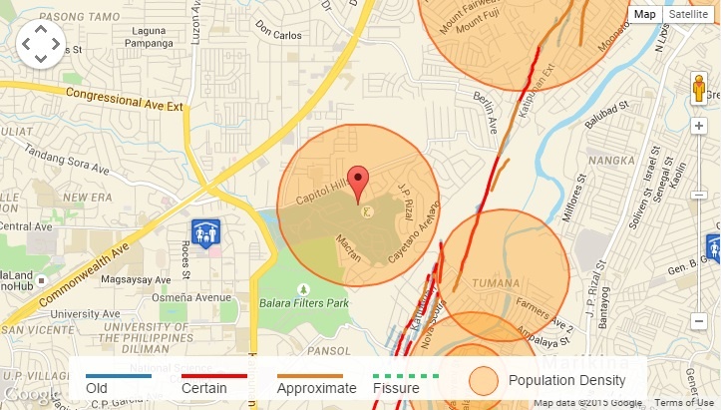

**Pansol**

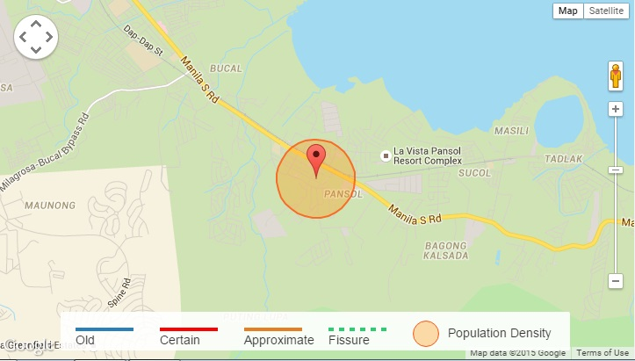

**White plains**

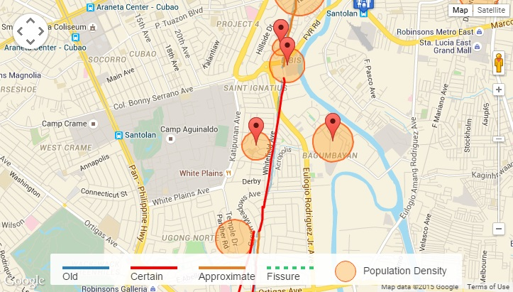

**Ugong Norte**

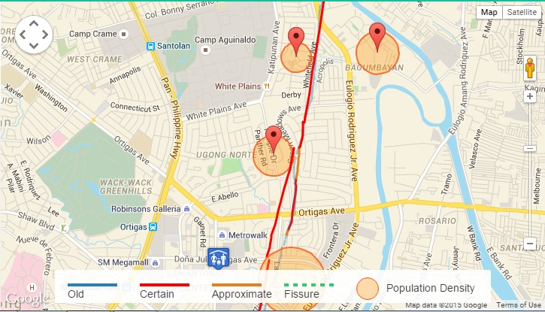

**Loyola Heights**

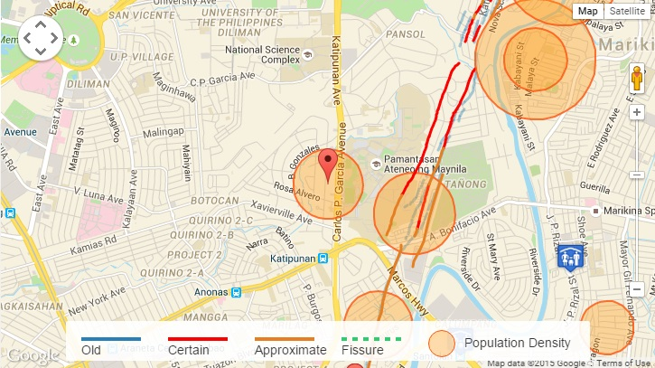

**Pasong putik proper**

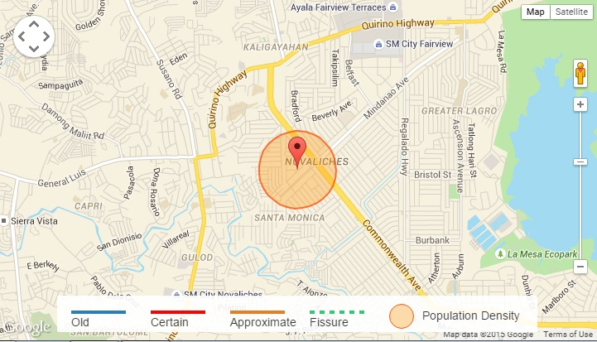

**Payatas**

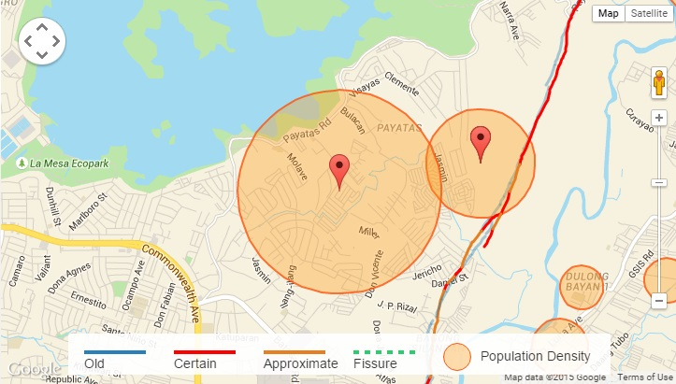

**Barangka**

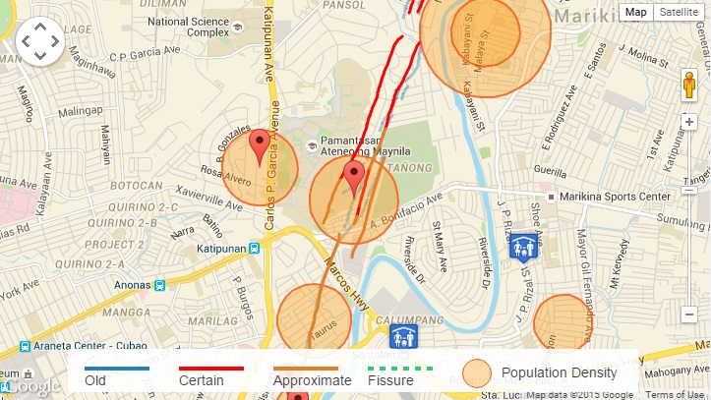

**Industrial Valley**

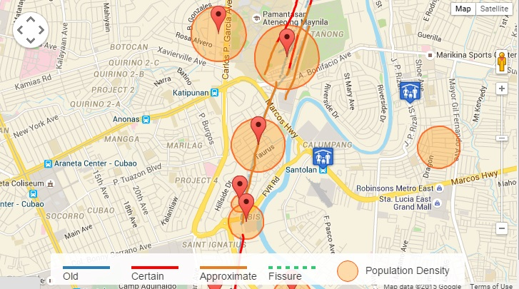

**Malanday**

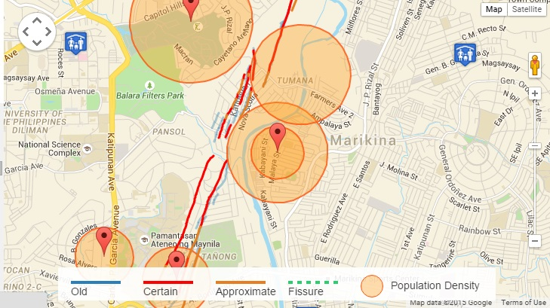

**Tumana**

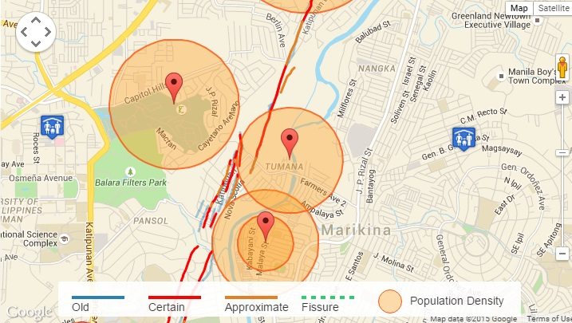

**Bagong Ilog**

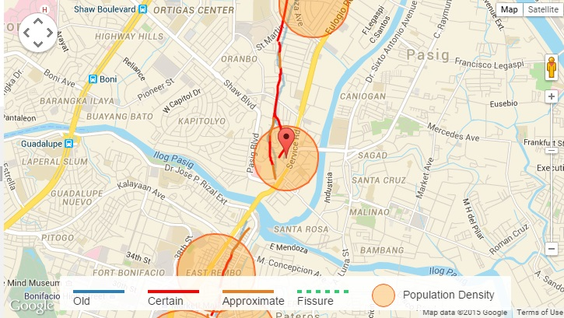

**Ugong Norte**



**East Rembo, Pembo, Rizal, Comembo**

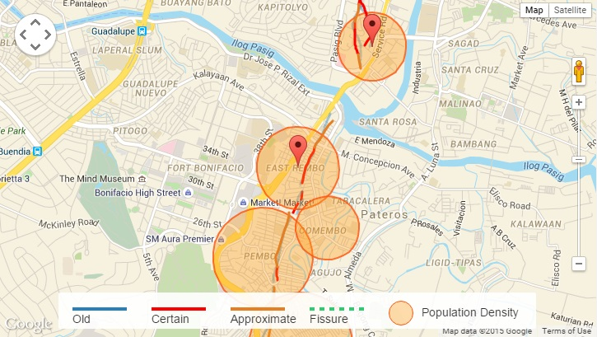

**Bagumbayan & Bagong tanyag**

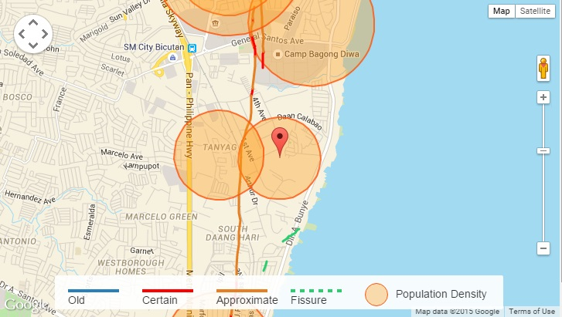

**Upper and Central Bicutan and Maharlika Village**

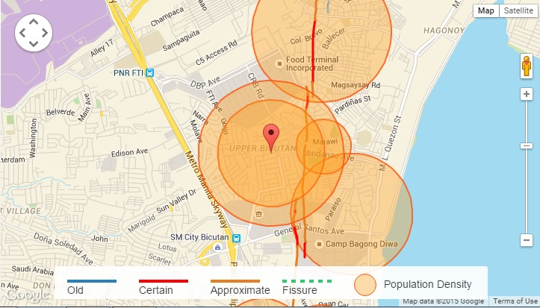

**Lower Bicutan**

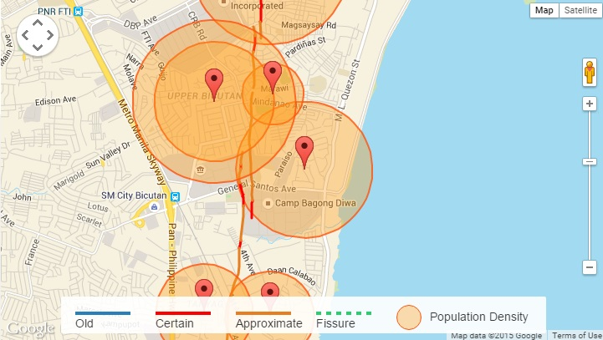

**Central Signal Village**

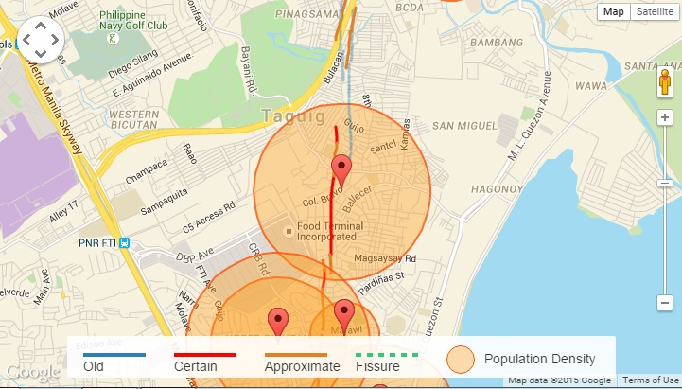

**Ususan**

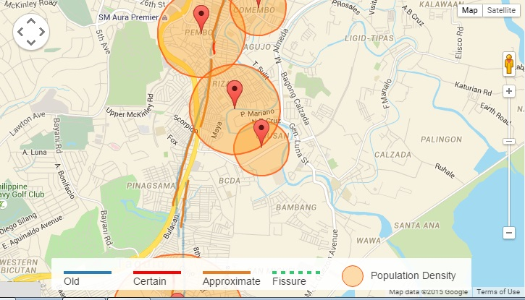

**Alabang and Bayanan**

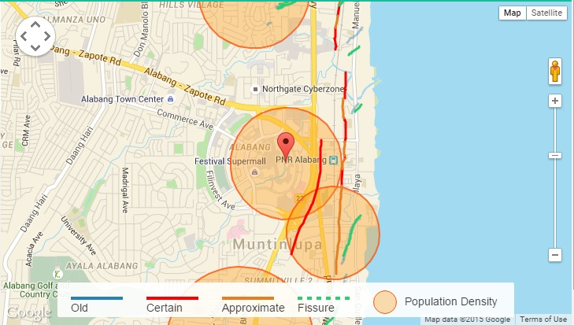

**Buli and Cupang**

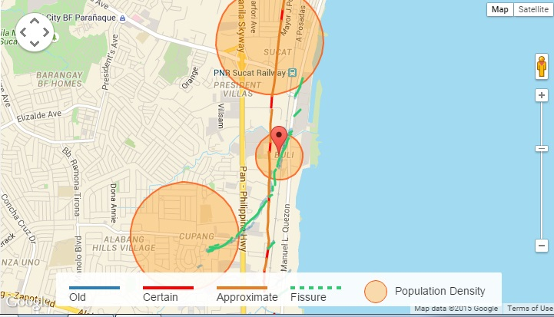

**Poblacion and Putatan**

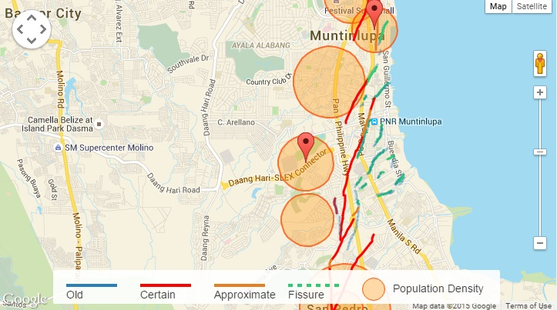

**Sucat**

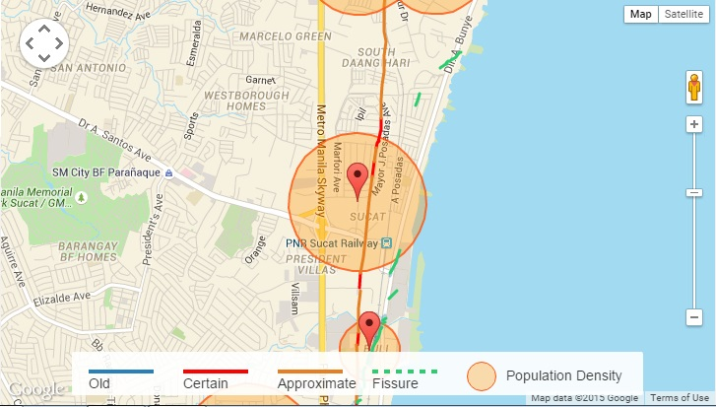

**Tunasan**

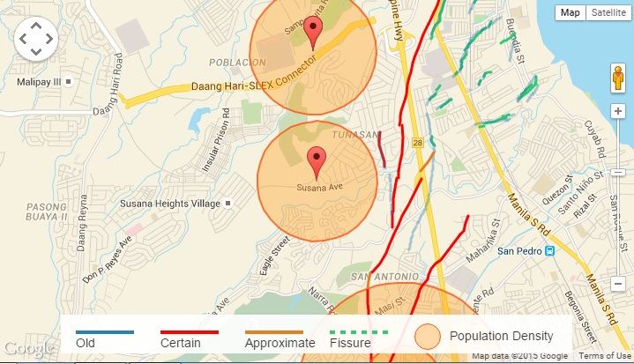

**San Jose Del Monte City**

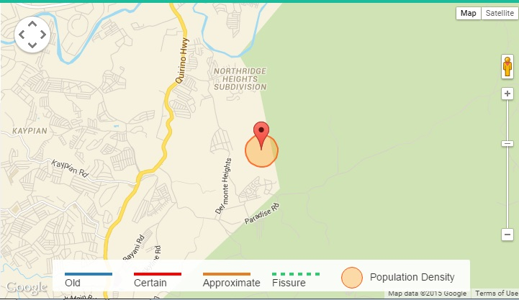

**San Pedro**

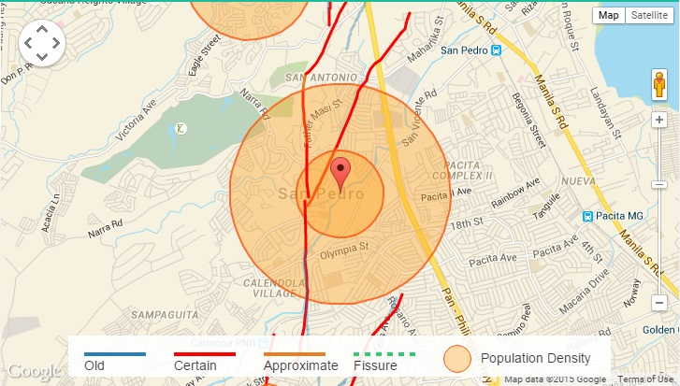

**Sto.Domingo**

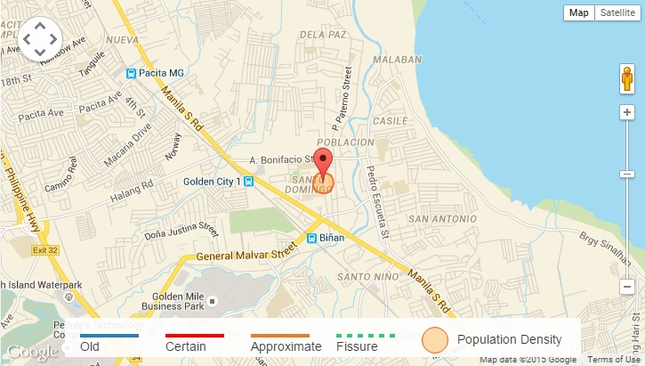

**Casile**

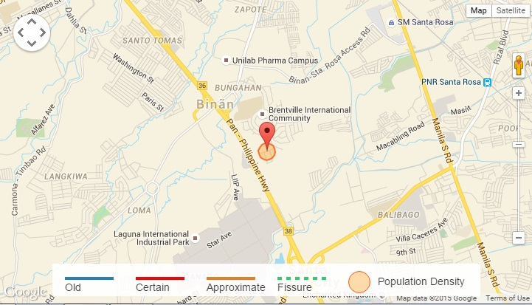

**Canlubang**

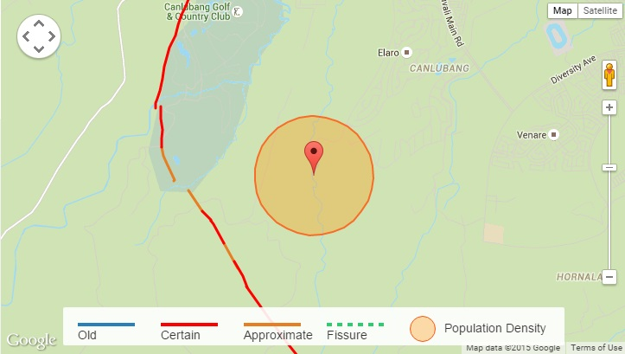

**San Jose**

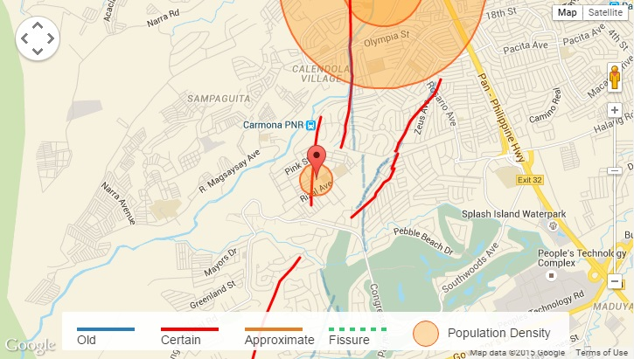

**Carmona**

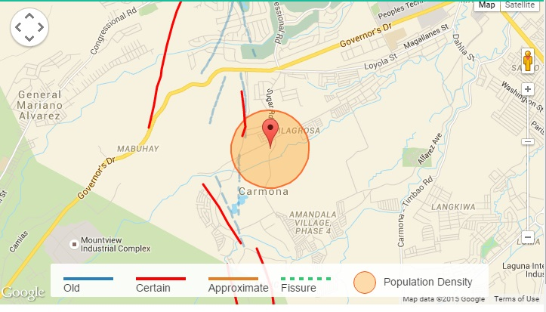

**Silang**

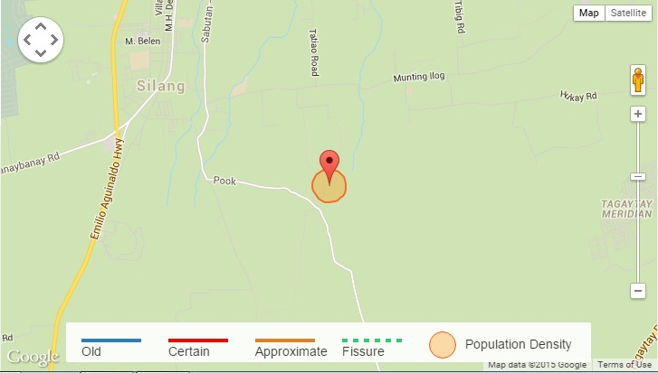

**East Valley Fault High-Resolution Maps**

**Ampid I**

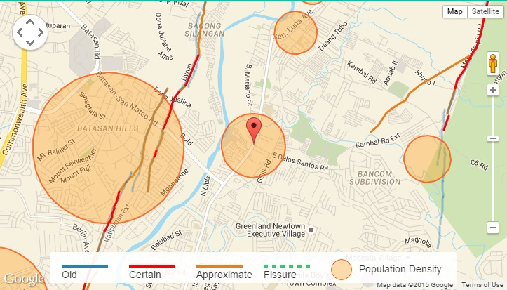

**Dulongbayan li, Guinayang, Guiltnangbayan li**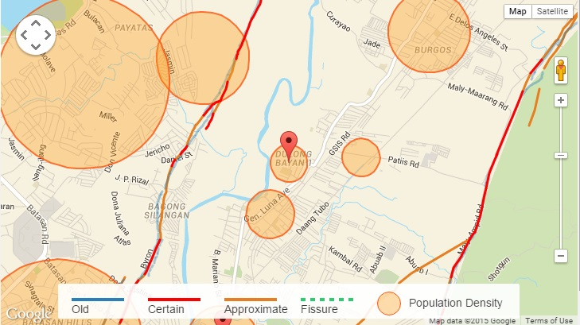

**Malanday**

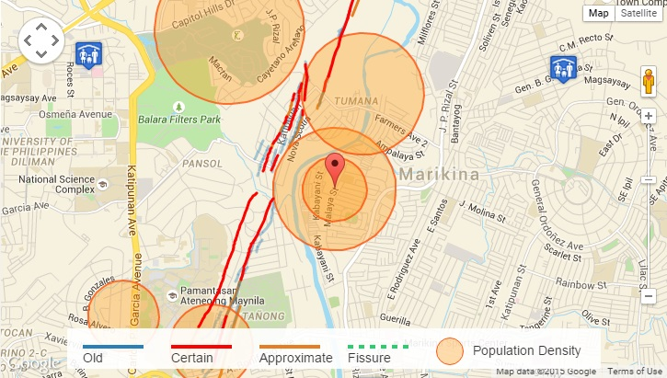

**Maly**

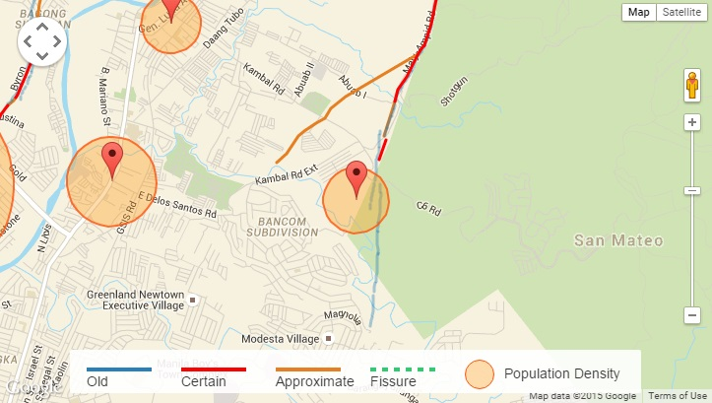

**Santa Ana**

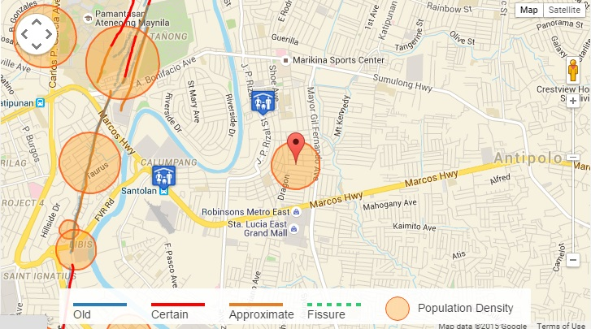

**Burgos**

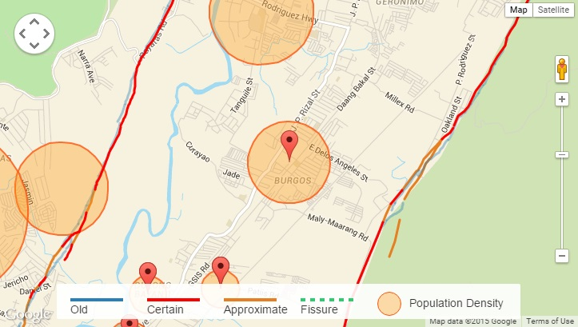

**Macabud**

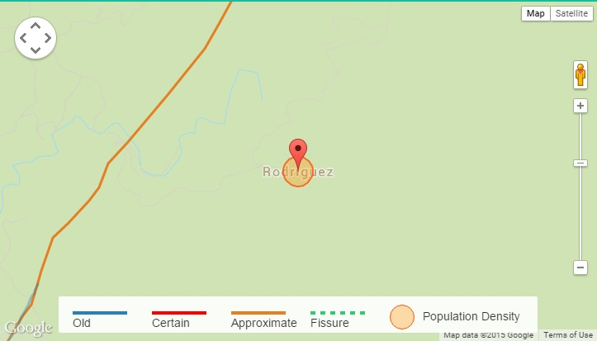

**San Jose**

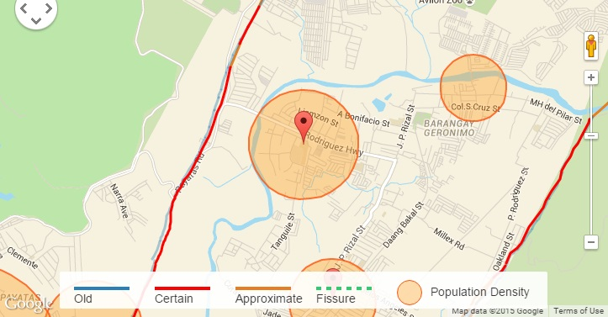

**San Isidro**

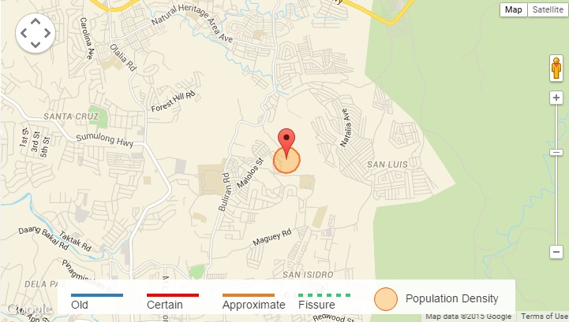

**San Rafael (Rosario)**

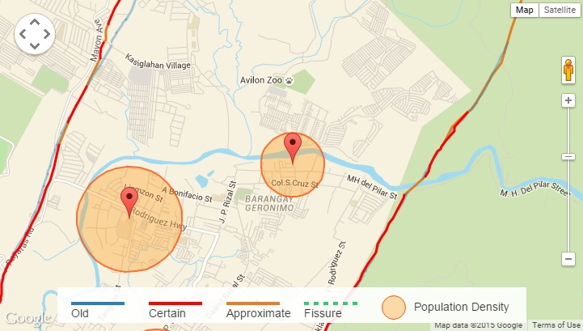

**Expected big quake**

The fault lines and location of fissures indicated in the map were based on old aerial photos of Phivolcs and field validation of Phivolcs researchers who visited the fault sites. Their findings were then translated into maps using 1:5,000 topographic maps from NAMRIA (National Mapping and Resource Information Authority). The handbook is prefaced with a guide on how to interpret it. Different types of lines indicate the location of active faults, fissures, and where faults coincide with fissures. Also indicated is the certainty of Phivolcs of the location of the fault and whether or not the fault is hidden by natural or man-made obstructions.

The [100-km West Valley Fault transects](http://www.rappler.com/move-ph/issues/disasters/93862-subdivisions-villages-west-valley-fault) at least 57 residential villages and subdivisions. This fault generates big quakes every 400 to 600 years, according to PHIVOLCS. The last major quake occurred more than 3 centuries ago, in 1658. Within 50 years, another big quake might happen – also, within our lifetime.

While the Philippine laws indicate that buildings should not be within the 5-meter buffer zone from either side of the fault, not being near the fault line does not necessarily mean that one is free from the impact of a huge earthquake.

The West Valley Fault is known to generate big quakes every 400 to 600 years, he explained. The last major quake happened 357 years ago in 1658, meaning another one can happen as soon as 43 years from now.

"Active faults do not follow averages. If it moves earlier, we need to prepare for possible movement within our lifetime," said Solidum.

The map should enable national and local governments, homeowners, building owners, and disaster officials to prepare for this eventuality.

Phivolcs warned that buildings should not be built on top of active faults or within a 5-meter bufferzone on either side of the fault.

Buildings that violate this rule are likely not to survive the rupturing of the ground when the faults move.

Solidum, however, warned that even buildings and persons outside the buffer zone will still feel intense shaking during a big earthquake.